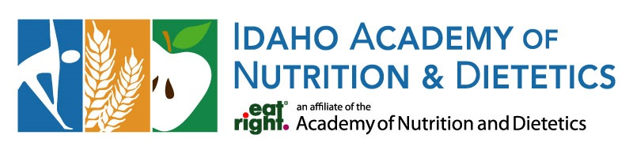

Board Election Statement
Name and Credentials: Misty Roberts, RDN, LD
Current Position/Organization:
Outpatient Telehealth with Nourish
Inpatient Clinical at Idaho Falls Community Hospital
Briefly describe your professional background and what you find most rewarding or interesting about your work.
Graduated with honors from Idaho State University
13 years of experience spanning inpatient clinical nutrition, psychiatric nutrition, long term care, community health, food service management, nutrition education, telehealth, precepting, and sports nutrition.
I have two things that I find equally rewarding.
- Building meaningful connections with people and helping them discover realistic ways to improve their health.
- Continuous learning about medicine, food and nutrition, the psychology of food, cultures, government policy, processes and procedures, and motivation.
What accomplishments or experiences best demonstrate your leadership, skills, or commitment to the dietetics profession?
I have demonstrated leadership through program development, team management, mentorship, and community engagement. What I am most proud of is my ability to bring people together, challenge traditional approaches, and create practical solutions. I am invested in advancing dietetics, and I strive to lead with empathy while driving meaningful change.
What skills, experience, perspectives, or personal attributes would you bring to the Board?
The experience I have across many areas of dietetics brings a strong understanding of both the opportunities and challenges facing dietitians across different practice settings.
I bring skills of strategic planning, program development, collaboration, problem-solving, and building meaningful partnerships. I have a genuine desire to understand different perspectives, and I value transparency, accountability, and inclusion.
Fun facts about you. (optional)
My family: Five humans, two fur babies, and one grand-kitty.
One word to describe me: Passionate!
Non-professional accomplishment: My partner and I have played in a city softball league every summer and fall for nearly a decade. I had never played a single game of softball before we started, and I was terrible… but now, I am asked to play a lot because I am pretty good.
Quirky habit: I collect gift cards… and then struggle to spend them! I tend to save them for that “special something” sometimes for over a year.
Claim to fame: I have a nephew who plays in the NFL.
Controversial breakfast opinion: Pop-Tarts are one of the worst breakfast foods, but donuts are an acceptable option. It’s complicated.

