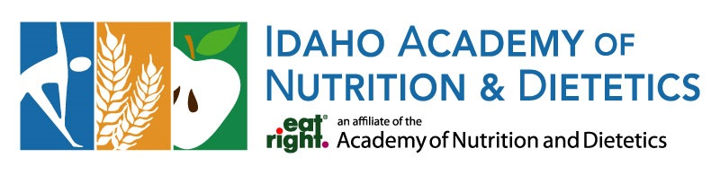

Board Election Statement
Name and Credentials: Marissa Rudley, MS, RD, LD
Current Position/Organization: Campus Dietitian at the University of Idaho, consultant with S&S Nutrition, Private Practice owner of Palouse Nutrition LLC.
Briefly describe your professional background and what you find most rewarding or interesting about your work.
As a registered dietitian of 15 years, I enjoy working in a diverse scope of practice. A typical week of work for me includes nutrition counseling to college students at the University of Idaho, working as a consultant dietitian in a skilled nursing facility and providing nutrition counseling in my private practice. I enjoy dynamic work in the dietetics field and enjoy helping others reach their healthiest potential with positive nutrition.
What accomplishments or experiences best demonstrate your leadership, skills, or commitment to the dietetics profession?
I’ve served on the Academy of Nutrition and Dietetics board in the past in the position of Nominating Committee North. With my years of experience at the University of Idaho, I get the opportunity to meet and provide some career experience for our future dietitians. As a fun aside, I joined the Nutrition Travel Exchange program and have had a lot of fun over the years with providing nutrition education abroad.
What skills, experience, perspectives, or personal attributes would you bring to the Board?
Since I work in a variety of different fields, from clinical dietetics to skilled nursing, I have a broad scope of experience. I am open-minded, innovation-forward, collaborative, and an advocate for dietitians in our field. I enjoy attending nutrition conferences and keeping up to date on nutrition trends and continuing education.
Fun facts about you.
I have my licensure in Idaho, Washington and Illinois.
I am married and have two daughters and slightly erratic labradoodle.

