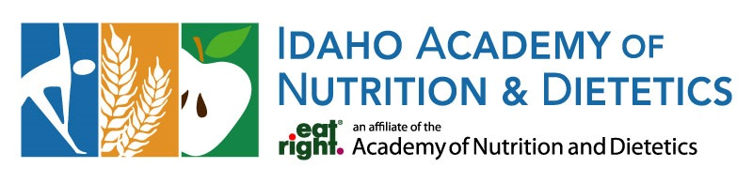

Board Election Statement
Name and Credentials: Jobeth Kuchar, MS, RD, CNSC, LD
Current Position/Organization: Clinical Nutrition Manger Lactation Services St. Luke’s Health system
Briefly describe your professional background and what you find most rewarding or interesting about your work.
I am a registered dietitian with nearly 20 years of experience, specializing in pediatric and neonatal nutrition. Throughout much of my career, I have had the privilege of caring for some of our most vulnerable patients in pediatric and NICU settings, helping support healthy growth and development during critical stages of life. In recent years, I have transitioned into leadership roles, where I am passionate about supporting and empowering healthcare teams so they can provide exceptional care to patients and families. My professional interests include human milk and lactation, pediatric malnutrition, and helping tiny humans thrive through evidence-based nutrition care.
What accomplishments or experiences best demonstrate your leadership, skills, or commitment to the dietetics profession?
Over the course of my nearly 20-year career as a registered dietitian, I have specialized in pediatric and neonatal nutrition, dedicating my work to helping infants and children achieve the best possible health outcomes. In recent years, I have advanced into leadership roles, where I have focused on supporting and developing dietitians and lactation consultants, mentoring staff, improving clinical programs, and advancing evidence-based practices. I am particularly passionate about human milk, lactation, pediatric malnutrition, and quality improvement initiatives that enhance patient care. My commitment to the profession is demonstrated through my leadership of multidisciplinary teams, support of staff development and preceptorship, and ongoing efforts to improve nutrition and lactation services for children and families across the communities we serve.
What skills, experience, perspectives, or personal attributes would you bring to the Board?
I would bring a unique combination of extensive clinical expertise, healthcare leadership experience, and a deep passion for advancing the nutrition profession. I offer a strong understanding of the clinical challenges and opportunities facing dietitians across healthcare settings. As a leader, I have experience building and supporting high-performing teams, mentoring emerging professionals, leading quality improvement initiatives, and fostering collaboration across disciplines. I am a thoughtful, compassionate, and solution-oriented leader who values diverse perspectives and believes in empowering others to succeed. I would bring a collaborative approach, a commitment to service, and a genuine desire to help strengthen and advance the dietetics profession for future generations.

Fun facts about you. (optional)
I graduated from the University of Nebraska-Lincoln in 2007. My family and I made the move from Nebraska to Meridian, Idaho, in 2015 and later settled in Twin Falls in 2020, where we've enjoyed all the outdoor adventures the area has to offer. I am a proud mom of three amazing kids: one has already graduated, another is about to graduate, and my youngest is in fourth grade. When I'm not working, I enjoy camping (from the comfort of a camper!), spending time with my family and our poodle, and exploring new hobbies. This year, I decided to garden and can food, which has been both a lot of fun and a lot of work!

