President-elect Nominees – Whitney Beck and Jaclyn St. John
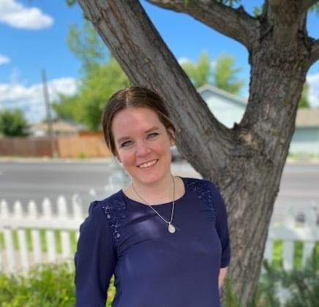Whitney Beck, RDN, LD, President-elect
How long have you been a member of Idaho Academy? I have been a member of the Idaho Academy since I was a student in 2013.
Why did you join Idaho Academy? Initially, I joined the Idaho Academy because it was strongly encouraged as a student. I continue to renew my membership annually because of the multitude of benefits I have found including (but not limited to) community, camaraderie, networking, experience, advocacy, and friendship.
How has membership in the Idaho Academy been of value to you and your practice? I have had so many professional opportunities that I may not have otherwise had as a member of the Idaho Academy. I have learned how to professionally advocate for myself, my interests, and my profession, and I have continued to hone my skillsets in leadership, public speaking, and project management. The collaborative spirit within the Idaho Academy routinely inspires me as I continue my journey as a dietitian.
Tell us about yourself, your job, and what you find most interesting about your job. I have been a dietitian for 10 years now. I started out in food service management and school nutrition and moved into gerontological nutrition where I stayed full time for over eight years. I still support skilled nursing facilities on an as needed basis, but I have found my passion truly lies in agriculture. We own a farm, and when I had the opportunity to work the farm full-time, I jumped at it! We currently raise both animals and crops including cattle, chickens, and hay/forage. We also started a micro bakery, a small orchard, and a tallow operation on the side. The most interesting part of my job is, quite literally, my job! There is never a boring day, and I find myself doing things every day that I never would have dreamed of doing previously. From operating, maintaining, and repairing heavy machinery; raising and caring for livestock and poultry; building and fabricating facilities and tools; planting, irrigating, harvesting, and storing hay and forage; running multiple pieces of a more than 100-year-old family business; and everything in between, there is never a dull moment. Supporting the management and smooth operation of a bona fide century farm, while diversifying and expanding our operations has been one of the most challenging, yet rewarding, things I have ever done.
How did you get into this field? My husband’s family has had a farm in Post Falls, Idaho that has been family owned and operated since 1904. My husband made the decision to leave his engineering career a few years ago, and came back to the farm full-time. He always enjoyed his engineering work, but I have also seen the pure joy that farming has brought into his everyday life. I love the field of gerontological nutrition, but I have always felt very drawn to our farm operations. I was working for a company in skilled nursing, and they were bought by a competitor. Unfortunately, my full-time position was eliminated, and I did not have a backup plan as it was unexpected. Ultimately, we did a trial run where I was full time on the farm, and I haven’t looked back since then! I continue to define my role and work to harmoniously blend farming and my nutrition knowledge as a Registered Dietitian.
Please list a few of your most recent accomplishments. Last year, I had the absolute honor of receiving the Emerging Dietetic Leader award as well as the Service award from the Idaho Academy of Nutrition and Dietetics for the Public Policy work that I contributed towards Idaho becoming a state that recognizes the Dietitian Licensure Compact. These awards were unexpected in the best way possible. It was incredibly humbling. On the farm, we have successfully diversified this year with the additions of a sourdough micro bakery, egg operation, and line of whipped tallow products. We are also in the midst of expanding crops to include a grape vineyard and a garlic field in addition to our cattle and forage.
What attributes could you bring to this position? I have always had a very collaborative spirit, and I believe that the key to sustainability is to ensure that key stakeholders are as involved as possible in decision making. I have held a board position for three years now, and I feel like I have a good understanding of the operations of the Idaho Academy of Nutrition and Dietetics. I am also very open-minded, and I have a curious attitude towards everything. Even if it is something I have done routinely for years, I always try to learn something new to continue to grow. I believe my growth mindset, along with my collaborative spirit and dedication to whatever I take on, will be of significant benefit should I be elected to this role.

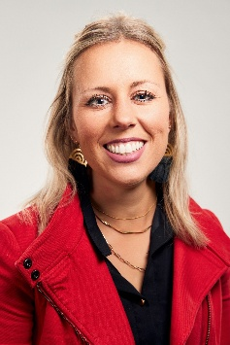 Jaclyn St. John, MS, RDN, LD, President-elect
How long have you been a member of Idaho Academy? 15 years
Why did you join Idaho Academy? I joined the Idaho Academy to continue learning and exploring the dietetics profession, as well as to network and stay connected with other like-minded professionals.
How has membership in the Idaho Academy been of value to you and your practice? Idaho Academy membership has brought me value in so many ways. The family of dietetics is tight knit and so incredibly important to get to know other dietitians and get involved to support one another to be the best we can be. I always look forward to dietitian events to connect with friends and colleagues in the profession.
Tell us about yourself and what you find interesting about your current position. Originally from Washington, I moved to Meridian 15 years ago to begin my dietetics career. My husband Cody and I have a 9-year-old daughter Chloe, 6-year-old son Jaxon, 2 dogs and 1 cat. In my free time I enjoy spending it with family and friends! I’ve been leading the Health Promotions programs and partnerships at Dairy West for 12 years. I love the work I do and the variety that each day brings. The people I get to work with to bring the programs and partnerships to our communities keep me coming back every day.
How did you get into this field? I wanted to live a healthy life and originally thought I’d be a group fitness instructor; after exploring with others in that field, they encouraged me to get a nutrition degree to support my future clients. It was in undergrad that I learned about the internship to obtain the RDN credential and knew I had to do it all!
Please list a few of your most recent accomplishments. Idaho Accomplished Under 40 from Idaho Business Review and Idaho Academy Recognized Young Dietitian of the Year Award
What attributes could you bring to this position? Leadership, Responsibility, Communication, Positivity, Woo, Responsiveness, Kindness, Joy, Confidence, Presence, Influence.
Treasurer Nominees – Mallory Summer and Adrian Griebel- Thompson
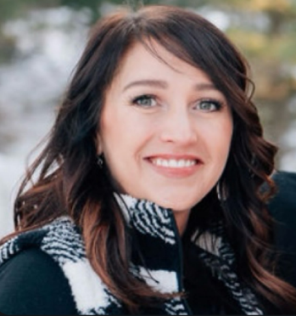Mallory Summers, MS, RDN, CLC, LD
How long have you been a member of Idaho Academy?
Of and on since 2011, about five years total.
Why did you join Idaho Academy? I initially joined as a student and continued my membership as a professional and a graduate student primarily to network with other dietitians and nutrition researchers within the state.
How has membership in the Idaho Academy been of value to you and your practice? I have really benefited from the various continuing education opportunities, but I have mostly enjoyed most the community of dietitians throughout Idaho. It has been beneficial to make connections where I have had the opportunity to learn, expand, and grow as a nutrition professional.
Tell us about yourself, your job, and what you find most interesting about your job. I am a mother of two and married to a first responder, which always keeps life interesting. I began my career as an outpatient dietitian at Portneuf Medical Center in 2014. A couple of years later, I went to work as a dietitian in WIC and eventually became the Southeast Idaho WIC Director. I am now a clinical assistant professor at Idaho State University in the Nutrition and Dietetics program. I also serve as our DPD Director for the department. The most interesting thing about my job, and what I enjoy most, is the enthusiasm of our students and the excitement they bring. Their motivation and energy are contagious, and it keeps me feeling excited about the field and privileged to be teaching the next generation of dietitians.
How did you get into this field? I was initially going to school to become a nurse, but after taking the introductory nutrition course, I realized my passion was for nutrition and preventive healthcare. Embarrassingly, I did not know that this was a field I could pursue until I met my RD professor. Even more embarrassing, I found out shortly after changing my major that my aunt was an RD for themilitary. She was a great resource for me as I navigated becoming a dietitian.
Please list a few of your most recent accomplishments.
My most recent accomplishment was that I just passed my Certified Lactation Counselor training exam for the second time, a certification that I let lapse during the pandemic. Within the last year, I left community nutrition to pursue academia and just began working on my doctorate, which has been challenging but very rewarding.

What attributes could you bring to this position? With my experience as both a director and manager of various programs and grants, I believe I have the professional and organizational skills necessary to fulfill the position of treasurer. I have experience with budgeting, which I hope will benefit the Academy and its members. I am excited to be considered for this service role.

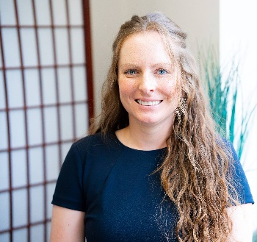Adrianne Griebel-Thompson, PhD, MS, RD, LD, CLC
How long have you been a member of Idaho Academy? 1½ years (February 2024 – current)
Why did you join Idaho Academy? I joined the Idaho Academy when I began working as an Assistant Professor and Extension Specialist at the University of Idaho. I believe it is important to support my profession and one of the ways I do this is by maintaining membership of the Academy of Nutrition an dDietetics along with my local chapter of the Academy.
How has membership in the Idaho Academy been of value to you and your practice? I attended the annual meeting that was held in Moscow in Spring 2024. I enjoyed networking with other dietitians across the state. I also enjoyed seeing the University of Idaho Dietetic students take on a leadership role in planning and organizing the meeting.
Tell us about yourself and what you find interesting about your current position. I am an Assistant Professor and Extension Specialist at the University of Idaho. I specialize in maternal and infant health with an emphasis in identifying mineral deficiencies and toxicities. I also measure mineral concentrations of human milk. I teach one graduate level course “Advanced Vitamins and Minerals.” And I run an Extension Program focused on teaching young children how to “Eat the Rainbow!” The most interesting thing about my job is that I get to learn something new every day. I think the most important thing that I have come to realize in my career is how much I don’t know, and that I should never assume that there isn’t new information about nutrition that I need to check before giving a recommendation.
How did you get into this field? When I chose nutrition as my field of study, I thought that knowing what to eat and how to feed my family to lead a healthy life is something that would be valuable whether I worked a day in my life. I see nutrition as a skill I use all day every day, not just at work.

Please list a few of your most recent accomplishments. I am currently breastfeeding my 9-month-old son and working full time. I have written two NIH grants that have been reviewed and scored and my score greatly improved on the second submission.

What attributes could you bring to this position? I am organized, punctual, friendly, and professional. I am also knowledgeable in nutrition and would enjoy taking on a leadership role in my profession.

SE Idaho Nominating Committee
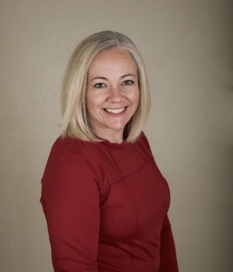 Misty Roberts, RDN, LD
How long have you been a member of Idaho Academy?
I have been a member since I was a student in 2009-2010 but have been off and on depending on my budget and some jobs I have worked where time didn’t allow much involvement.
Why did you join Idaho Academy?
I joined the Idaho Academy to be more involved in moving dietetics forward in Idaho, network with new and past colleagues and friends, and to get CEU’s from the conference.
How has membership in Idaho Academy been of value to you and your practice?

Membership in the Academy has benefited me by providing up-to-date, evidenced based information and continuing education so that I can stay informed. Membership also provides countless networking and involvement opportunities.

Tell us about yourself and what you find interesting about your current position.
I have three children, one adult son, a teenage daughter, and a seven-year-old… because why not experience all phases of parenthood at once?? My partner and I have two dogs, and we enjoy playing co-ed softball together. I enjoy the outdoors, reading, listening to music, lifting weights, and going on as many lunch and coffee dates with friends, or my sisters, as often as my budget (or theirs) will allow. I am currently trying to learn Spanish and it’s hard… but I am determined to get to a point that I can confidently say that I am bilingual.

My current job as the Nutrition Education Manager at the Idaho Foodbank has been challenging in new ways but has also allowed me for me to spend with my family. I can support groups of people that I care deeply about by providing nutrition education and other resources, and a focus on making a social and economic impact. It has been such a pleasure to connect, or reconnect, with individuals and groups all over Idaho that share my core values and vision for a healthy and food secure Idaho. I work with several organizations across Idaho to provide nutrition education to low-income households to make the healthy choice an easy choice. I help support pantries with nutrition information and other resources, collaborate with healthcare partners to meet the needs of areas that need help the most, and manage the nutrition curriculum and programs offered throughout the state. I also write the menu for the Idaho Foodbank backpack program which I really enjoy! I have found that the most interesting, and the most frustrating, part of my job is navigating the political changes as they intermingle with the non-profit sector.

How did you get into this field?

I grew up in a small Idaho town and moved to Pocatello to attend college at ISU as a music performance major. I changed my major a couple times and then put my education on hold to start my little family. In 2008, when I had considered what I really wanted to be when I grew up, I had the opportunity to return to school in 2008 to pursue my degree in dietetics. I wanted to become a dietitian because I had lost about 40 pounds, and I thought I wanted to help others do the same. While I discovered that I did not really want to do that, I still made the right career path choice. I fell in love with clinical dietetics right away but also worked a part-time job at a rehab facility as a dishwasher and foodservice worker at the hospital – which really developed my affinity for foodservice. When I graduated and completed my internship, I took a part-time position at Portneuf Medical Center as a clinical RDN. I was raising two little kids alone, so I also worked in the back of the house in various positions from diet aide to bulk production cook. As a side gig, I did outpatient diabetes counseling one day a week. I enjoyed working at Portneuf, but a full-time clinical dietitian position opened at State Hospital South and I was fortunate to have worked there for 6 years before coming back to Portneuf as a full-time clinical dietitian who then moved into Patient Services Manager in food and nutrition services. I found that I really thrive in food service management, but that job turned out to be incredibly taxing on my mental health, at the time, for various reasons. I came across my current job at the Idaho Foodbank while “doom scrolling” random operations management positions. Changing the trajectory of my 12-year career to being in community nutrition at a non-profit was a shock to my system but has been well worth the growing pains.

Please list a few of your most recent accomplishments.

My most recent accomplishments have been growing the Idaho Foodbank presence in South Central Idaho as there is not a warehouse in that region and staffing has been inconsistent. Prior to my position at the Idaho Foodbank, I was awarded recognition in leadership for my role in implementation of a new menu, ordering system, and a complete overhaul of processes in FNS. In my previous roles, there was little space for additional areas of growth outside of work and family life.

What attributes could you bring to this position?
The attributes I can bring to this position are my team-oriented approach in leadership and collaboration and my passion for supporting other leaders of the profession. I value diversity and inclusion. My experience and knowledge of clinical, foodservice, and community nutrition gives me insight into leadership traits that can move the profession forward. I align with mission driven objectives and strive to engage stakeholders effectively with professional communication and relationship building.

SW Idaho Nominating Committee Member

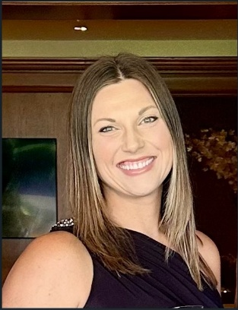 Teresa Brennan, RD, CNSCS, CGHS

How long have you been a member of Idaho Academy? ~1 yr, joined after moving to Idaho.

Why did you join Idaho Academy?

I have been excited about the opportunity to re-join the Academy and to connect with more Idaho Academy members.

How has membership in the Idaho Academy been of value to you and your practice?

Prior to moving to Idaho, I was very involved in the Seattle Dietetics Academy and sat in many board positions over my tenure. After taking a few years in remote work when my boys were very young, I have had the opportunity to get more involved in the Idaho Academy as my job has better aligned with my community. I am very excited to participate in the Idaho Academy.

Tell us about yourself, your job, and what you find most interesting about your job.

I have recently moved into the Clinical Nutrition Manager role within St Lukes after 3 years as a Clinical Dietitian in Wood River. I have been blown away by the incredible skills and talent of our local RDs. It has been such a rewarding opportunity to support an amazingly talented group of dietitians and diet techs in this new role.

How did you get into this field?

I was initially exposed to dietetics when I was 12yrs old. I was able to be seen by a dietitian during a time when my mom wasn’t sure how to talk about my changing body. At that time, I felt really fortunate to have the support and opportunity to learn about how food fuels the body and how it could change how I felt. It opened up my heart to the science of food and nutrition, and I was hooked. During high school, I was able to take 2 periods as career exploration. I was able to shadow a dietitian and was soon researching how to obtain my RD credential.

Please list a few of your most recent accomplishments.

I was able to participate in a 1yr Professional Development Program (Professional Advancement Through High performance and Skill (PATHS). My goal was to align our enteral nutrition practices with current evidence-based guidelines by discontinuing the routine measurement of Gastric Residual Volumes (GRVs) for Adult enterally fed patients, except in specific high-risk populations. I participated in the CDR/AND 2024-2025 Mentorship for Quality Improvement in Nutrition and Dietetics and I recently obtained the credential of Board Certified Specialist in Digestive Health.

What attributes could you bring to this position?

I hope to build strong relationships through networking, my commitment to professional development, experience by serving on the nominating committee (Seattle Dietetics Association), my interest in promoting evidenced based practice and my passion for advancing our profession and supporting fellow dietitians.

Megan Seal, MPH, RDN, LD
Megan Seal, RDN, LD, MPH, has served as an appointed member of the Idaho Academy of Nutrition and Dietetics Board since 2017, holding multiple leadership roles including Public Policy Coordinator and, most recently, Foundation Chair. Her career in dietetics has centered on the intersection of nutrition and public health, with extensive experience addressing food insecurity and chronic disease prevention across Idaho communities.
Currently, Megan is a stay-at-home mom while continuing freelance work in nutrition. Most recently, she collaborated with the University of Idaho to pilot a youth weight management program in Southern Idaho. Outside of professional pursuits, Megan enjoys being creative, spending time with her family, and exploring the Boise foothills.

